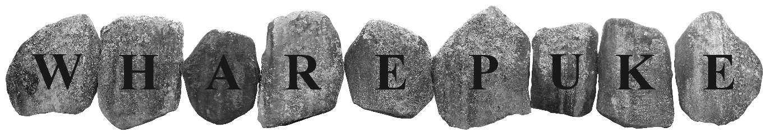
SCULPTURE PARK
www.art-park.co.nz
PROPOSAL/SUBMISSION FORM:
By email to:
info@art-at-wharepuke.co.nz
or
Post on CD/memory stick to:
Wharepuke Sculpture Park
190 Kerikeri Road
Kerikeri 0230

NAME: Click or tap here to enter text.
ADDRESS: Click or tap here to enter text.
EMAIL: Click or tap here to enter text.
YOUR WEB SITE: Click or tap here to enter text.
PHONE: Click or tap here to enter text.
BANK ACCOUNT DETAILS FOR PAYMENT OF SALES:Click or tap here to enter text.
GST REGISTERED? YES ☐ NO ☐ GST NO. Click or tap here to enter text.

PROPOSAL: There’s no limit on the number of proposals but please send a separate form for each proposal you wish to submit – artists are encouraged to visit the garden for site specific proposals. Proposals can be made at any stage of the working process, i.e. we are happy to hear ideas, concepts etc. and then to work towards realising them.
TITLE OF WORK: Click or tap here to enter text.
MEDIUM/MATERIALS: Click or tap here to enter text.
DIMENSIONS: Height (cm) Click or tap here to enter text. x Width (cm) Click or tap here to enter text. x Depth (cm)Click or tap here to enter text.
DATE OF COMPLETION: Click or tap here to enter text.
HAS THE WORK BEEN EXHIBITED ELSEWHERE BEFORE? Y ☐ N ☐
WHERE? Click or tap here to enter text. WHEN? Click or tap here to enter text.
IMAGE(S) OF ACTUAL WORK INCLUDED Y☐ N☐
IMAGE OF SIMILAR WORK INCLUDED IF PROPOSED WORK NOT YET COMPLETED Y ☐ N☐
RETAIL SALE PRICE (including 40% commission) or NFS: $Click or tap here to enter text.
ARTIST STATEMENT IN SUPPORT OF PROPOSAL (PRINT READY FOR GUIDE BOOK, WEB SITE): Click or tap here to enter text.
DOES WORK HAVE ANY SPECIAL INSTALLATION OR ON-GOING MAINTENANCE REQUIREMENTS? Click or tap here to enter text.
HAVE YOU VISITED WHAREPUKE? Y ☐ N ☐
IF SO, DO YOU HAVE A PARTICULAR SITE IN MIND? Click or tap here to enter text.
(N.B. We will work in consultation with the artist but final siting of works will be at the discretion of the curators/directors of Art at Wharepuke)
WHERE DID YOU HEAR ABOUT THIS OPPORTUNITY?Click or tap here to enter text.

DELIVERY OF WORKS
Artists are responsible for delivery and pick up of works. We will negotiate time frames with accepted artists.
Artists are responsible for insurance of works in transit and while on-site. Art at Wharepuke does not accept liability for any damage to works.

Please see detailed Terms and Conditions PDF.

APPLICATION PROCESS:
There are no deadlines for proposals/submissions
Please Include:
- Application form detailing proposal – Word or PDF format ☐
- Short bio, CV ☐
- Image(s) of proposed or similar work – (images can be the work, drawings, maquette etc.) Please label Jpegs ‘YourName_Title’ e.g ‘MarySmith_TheKiss’ ☐
Contact/Questions:
Mark Graver/Tania Booth
info@art-at-wharepuke.co.nz

I agree to the terms and conditions as detailed in this proposal and on the Terms and Conditions PDF

Artist’s signature: ................................................................................. Date: .....................

